8.75: First consider the motion after the collision. The combined object has mass 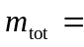25.0 kg. Apply 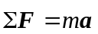 to the object at the top of the circular loop, where the object has speed 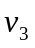.
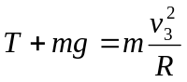
The minimum speed 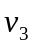 for the object not to fall out of the circle is given by setting 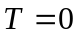. This gives 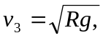where 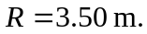

Next, use conservation of energy with point 2 at the bottom of the loop and point 3 at the top of the loop. Take  at the point 2. Only gravity does work, so

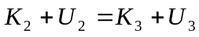
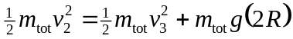
Use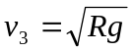 and solve for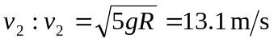
Now apply conservation of momentum to the collision between the dart and the sphere. Let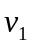 be the speed of the dart before the collision.
